INSTITUTO POLITÉCNICO NACIONAL

Centro de Estudios Científicos y Tecnológicos No. 9

Juan de Dios Bátiz Paredes

March 2024

PRACTICE 2

1. Answer the following exercise and send the results <https://www.liveworksheets.com/w/en/english-second-language-esl/7027385>

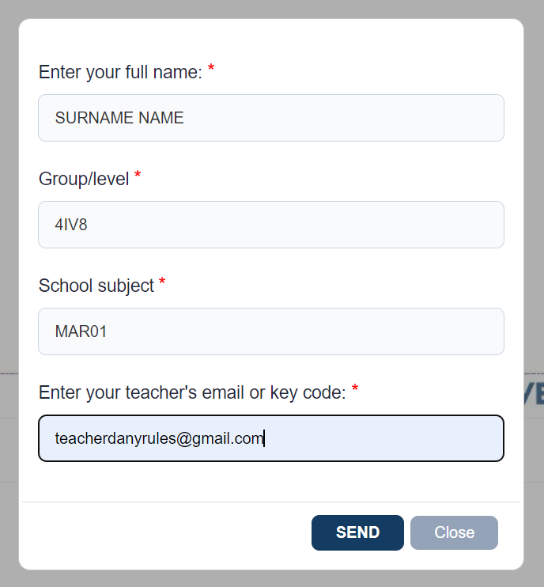

II. Answer the following <https://wordwall.net/resource/12962394/past-simple> and paste the screenshot.

III. Watch the following video [Lights Out - Who's There Film Challenge (2013)](https://www.youtube.com/watch?v=FUQhNGEu2KA&ab_channel=ponysmasher) and write 5 sentences using past, describing it

|  |  |
| --- | --- |
| 1 | When the lights went out, a person would appear |
| 2 | The monster turned off the lights in the house |
| 3 | The lady was afraid that the light would go out |
| 4 | When the lights went out, the lady was scared |
| 5 | The lady hid under the blankets out of fear |